# **PLUGGING INTO THE FUTURE : AN EXPLORATION OF ELECTRICITY CONSUMPTION PATTERN**

**TEAM ID: NM2023TMID02292**

TEAM SIZE: 3

TEAM LEADER: N.PRAGATHI

TEAM MEMBER: R.MOHANA

TEAM MEMBER: P.V.NARMATHA

**INTRODUCTION**

* + - * India is the world's third-largest producer and third-largest consumer of electricity.
      * Analysing Electricity Consumption in India from Jan 2019 till 5th December 2020. This dataset contains a record of Electricity consumption in each states of India, here we are going to analyse State wise , Region wise and Overall Electricity consumption in India.

**PROBLEM DEFINITION & DESIGN THINKING**

**EMPATHY MAP**

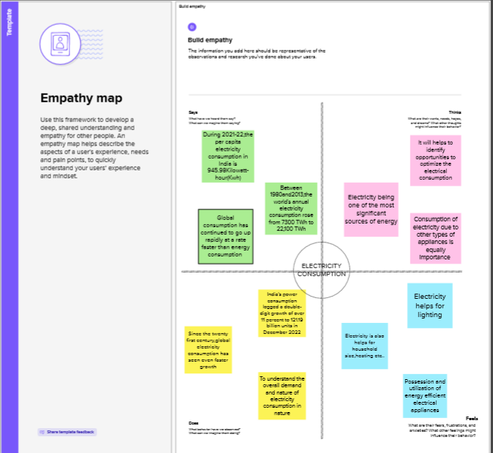

**IDEATION & BRAINSTROMING MAP**

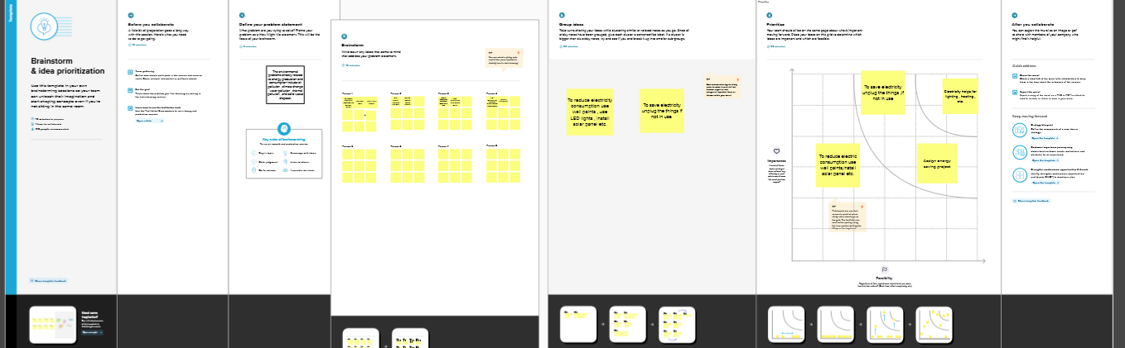

**RESULT SHEET 1**

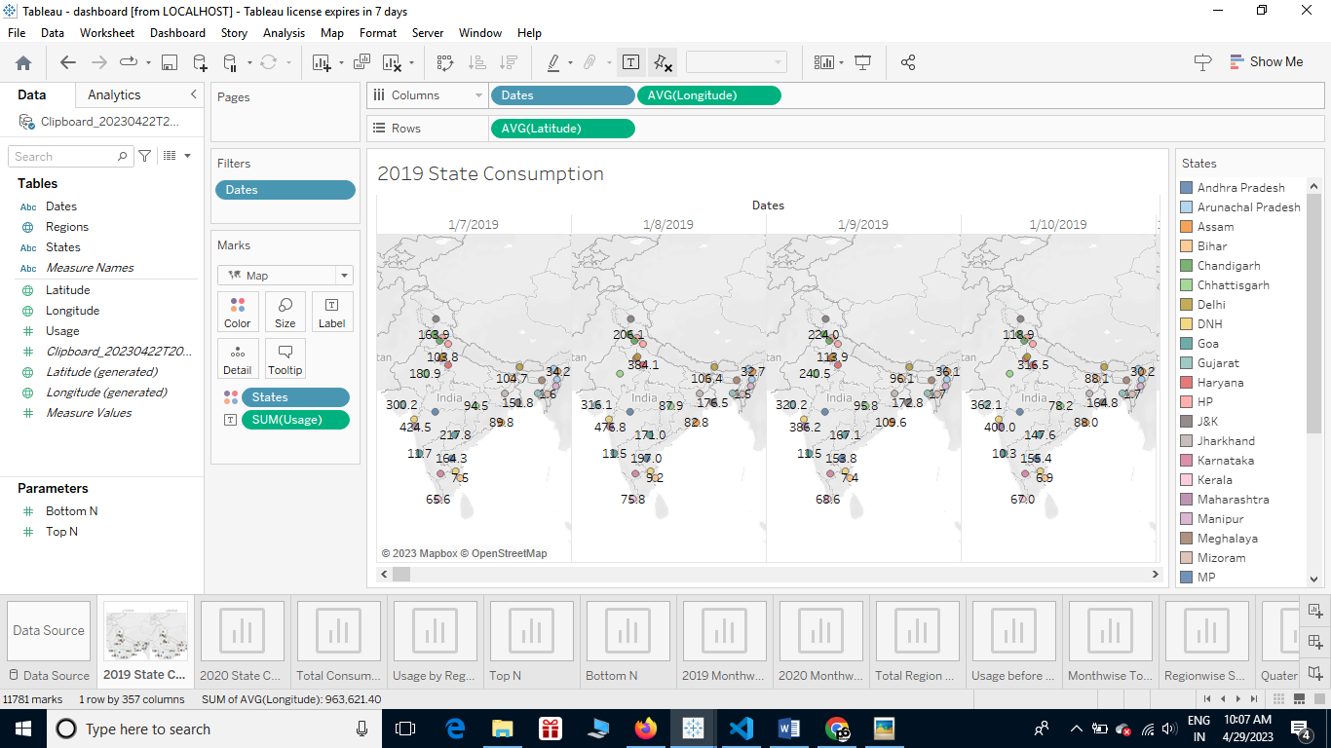

**SHEET 2**

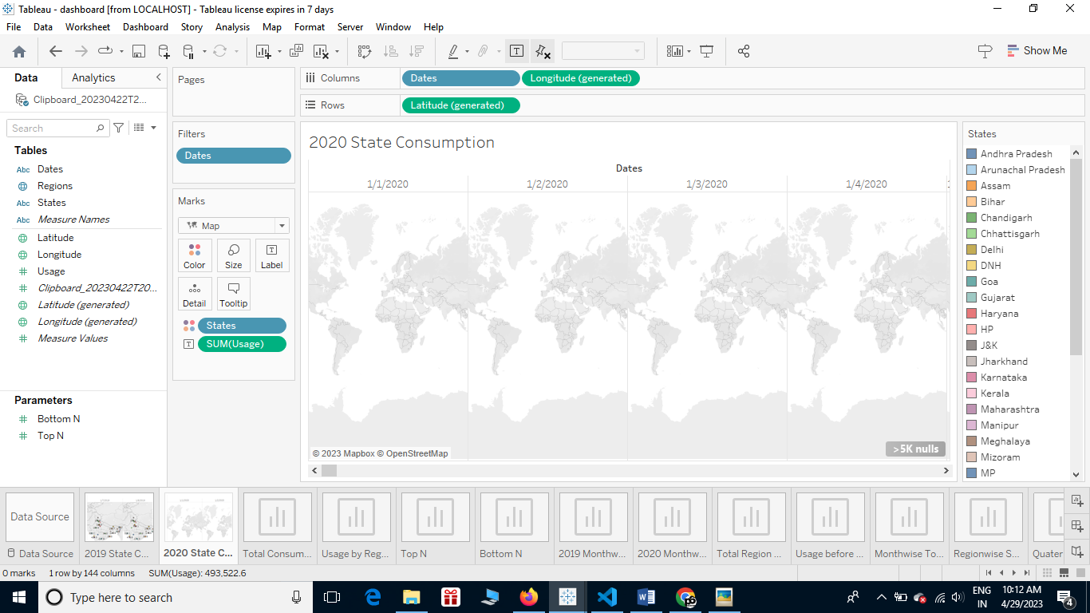

**SHEET 3**

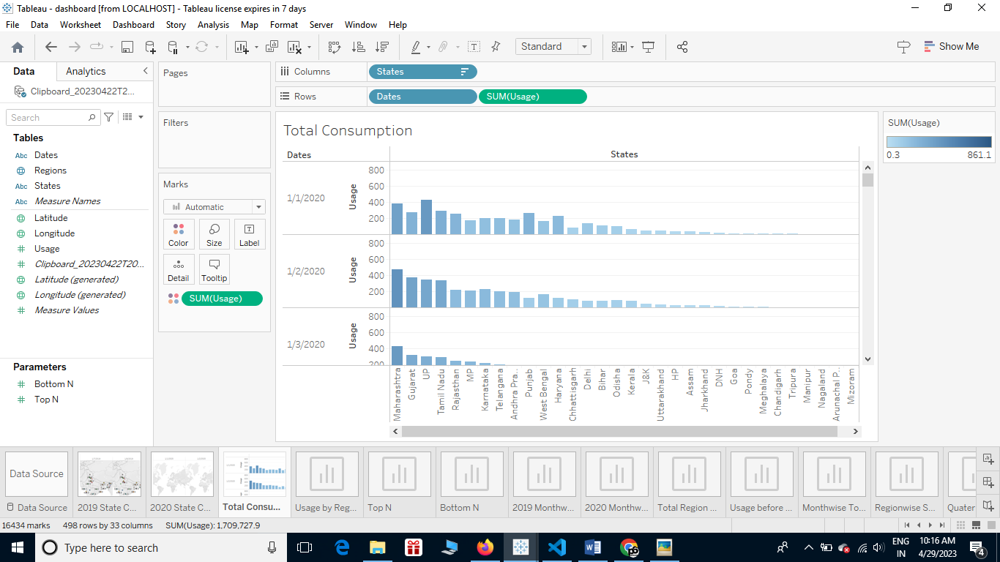

**SHEET 4**

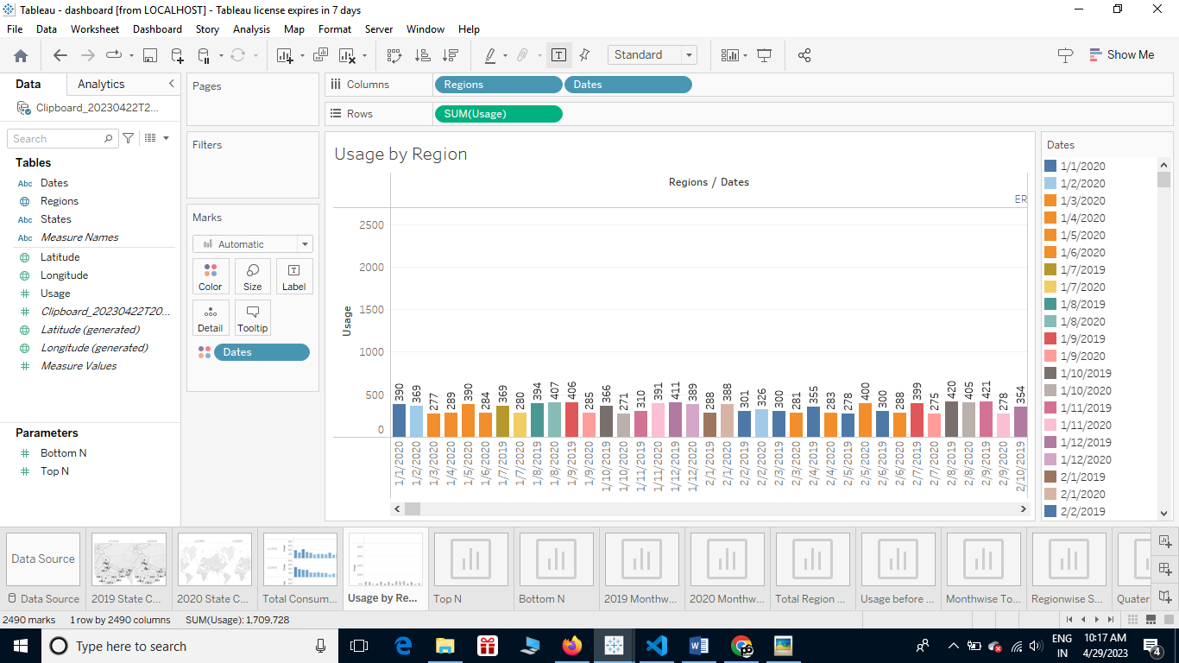

**SHEET 5**

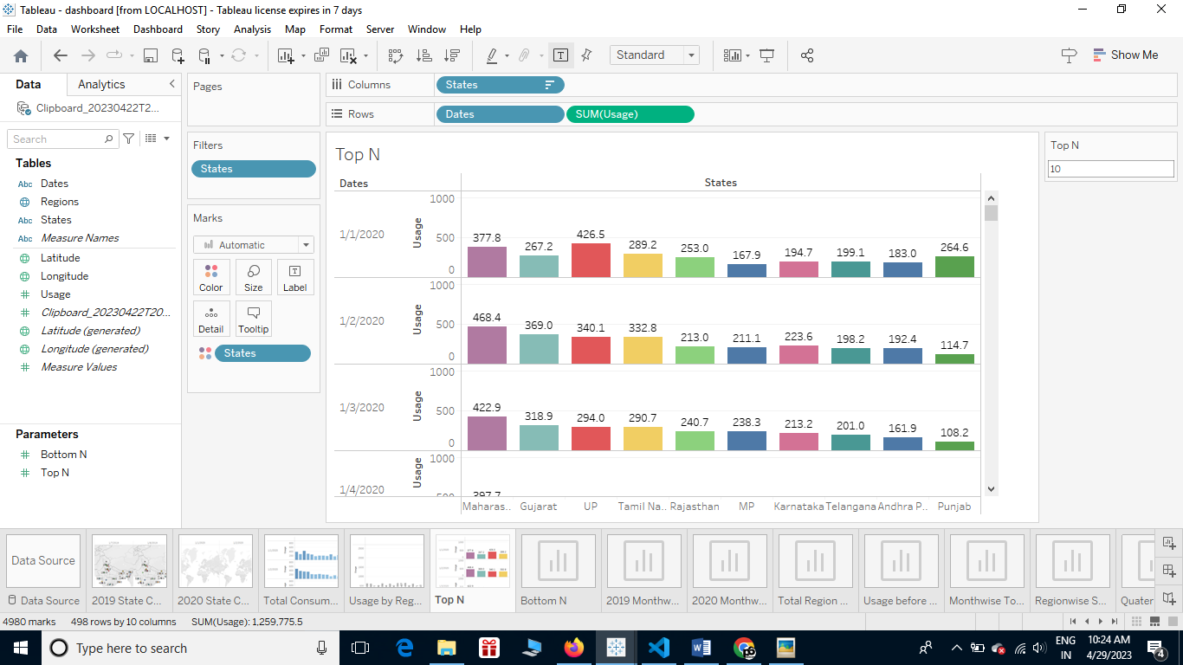

**SHEET 6**

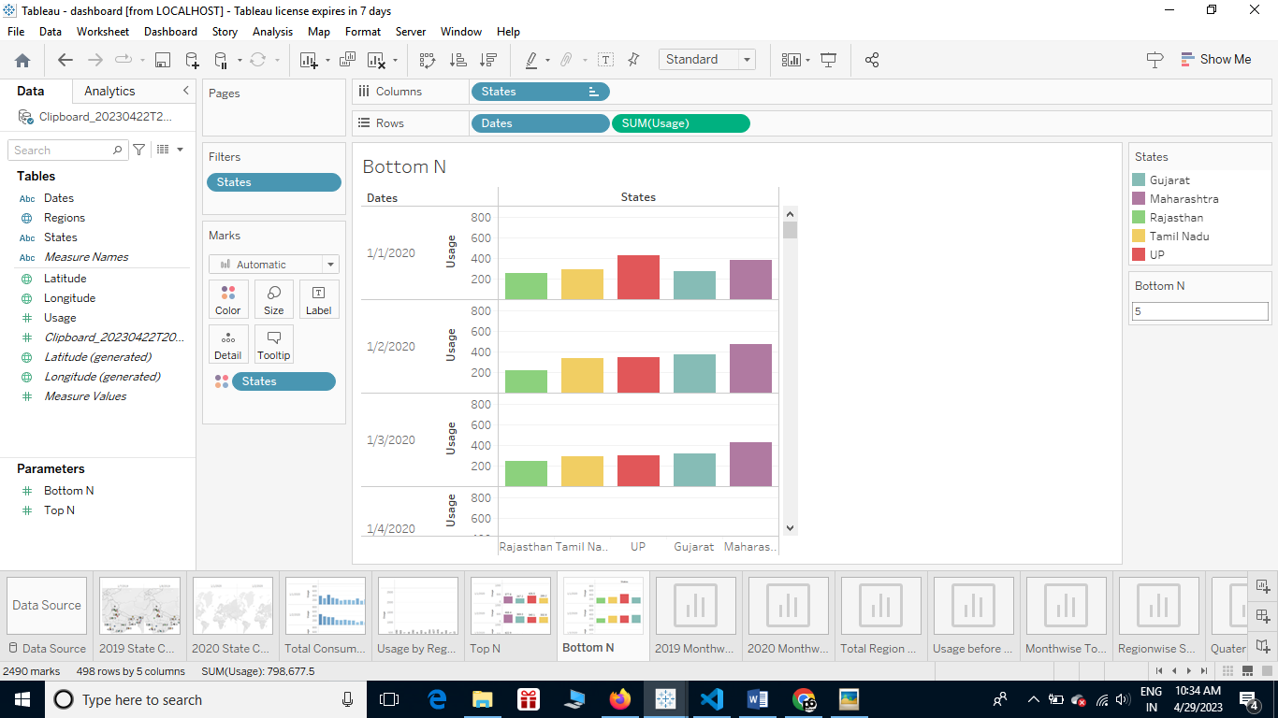

**SHEET 7**

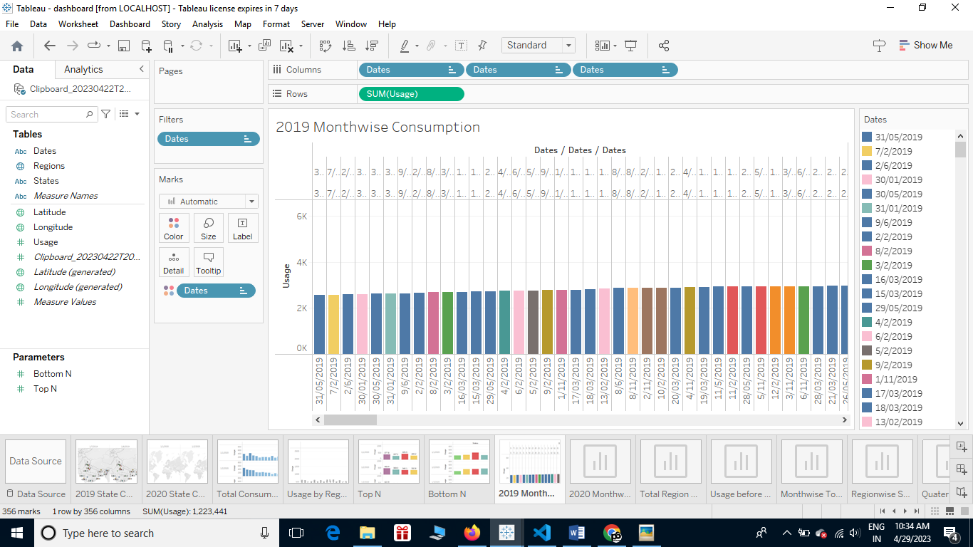

**SHEET 8**

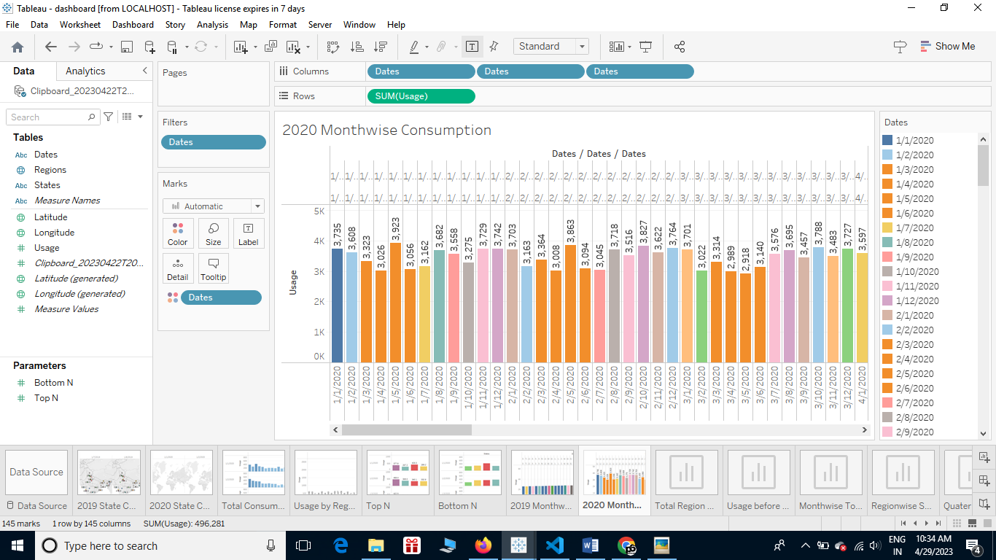

**SHEET 9**

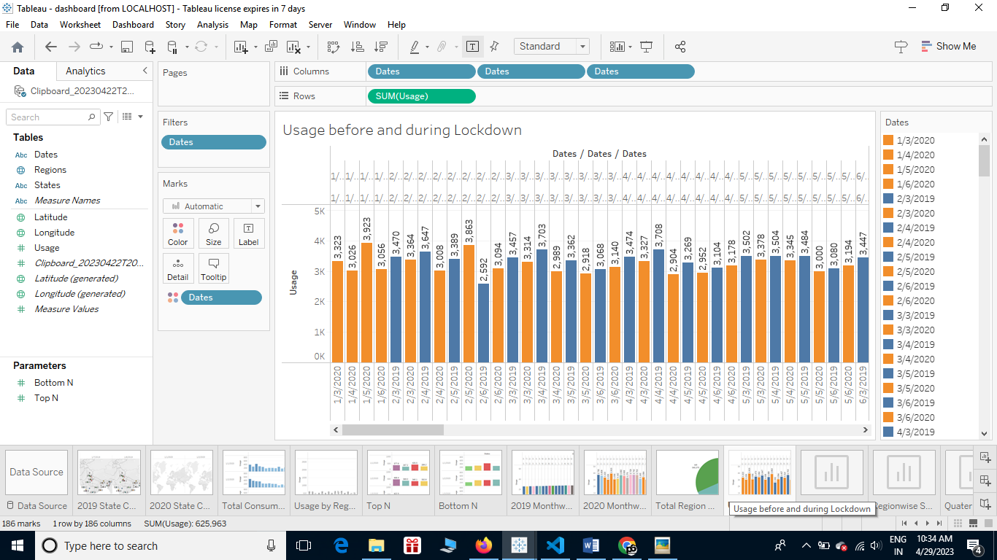

**SHEET 10**

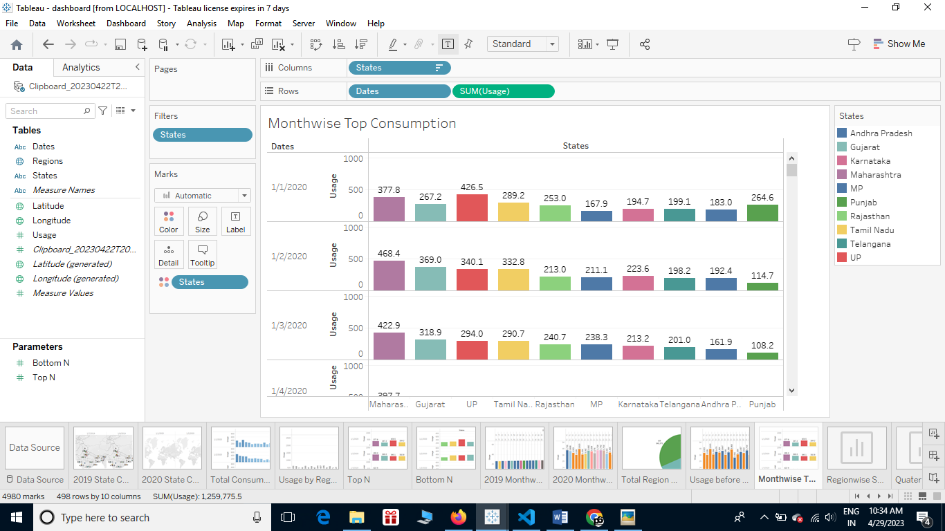

**SHEET 11**

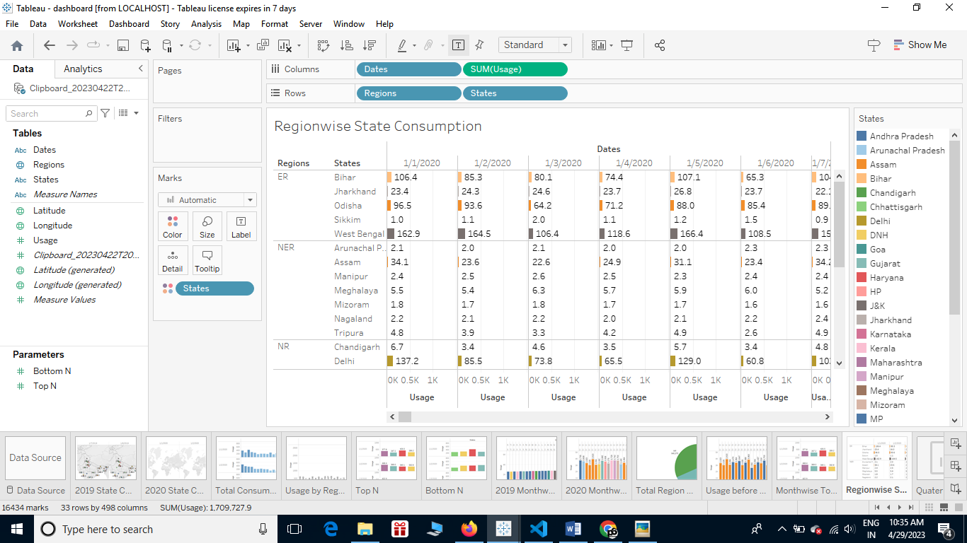

**SHEET 12**

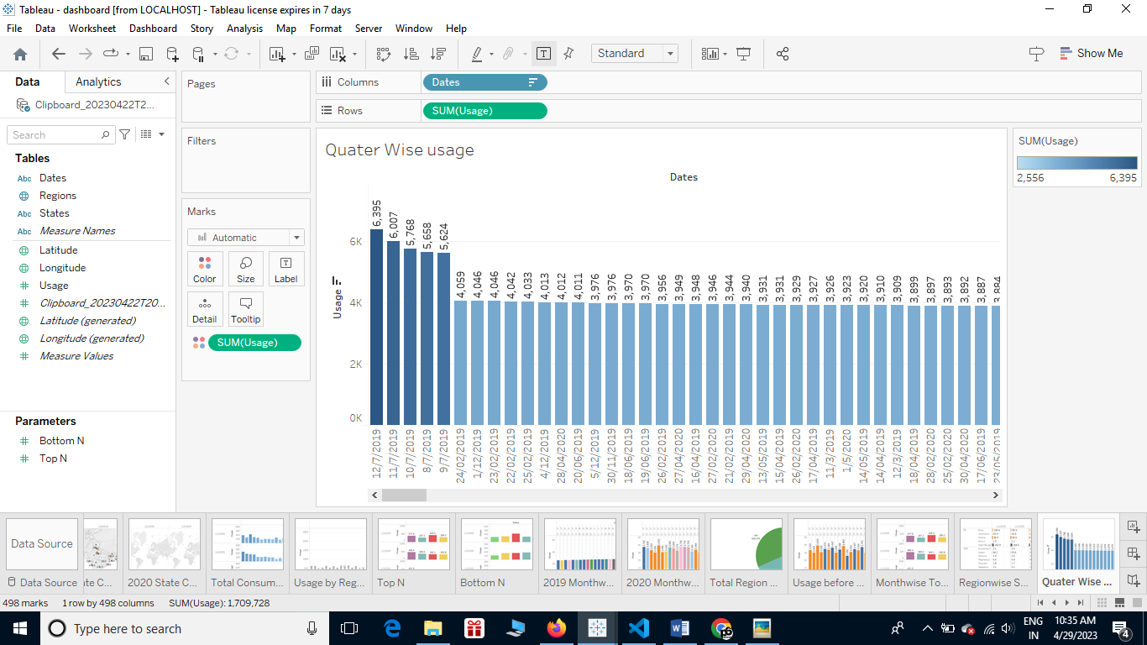

**SHEET 13**

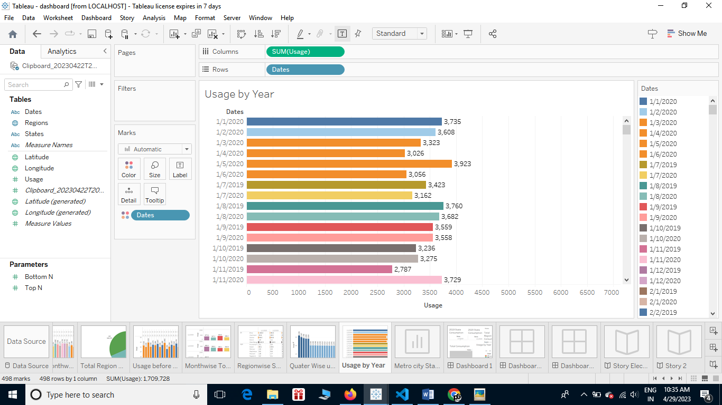

**SHEET 14**

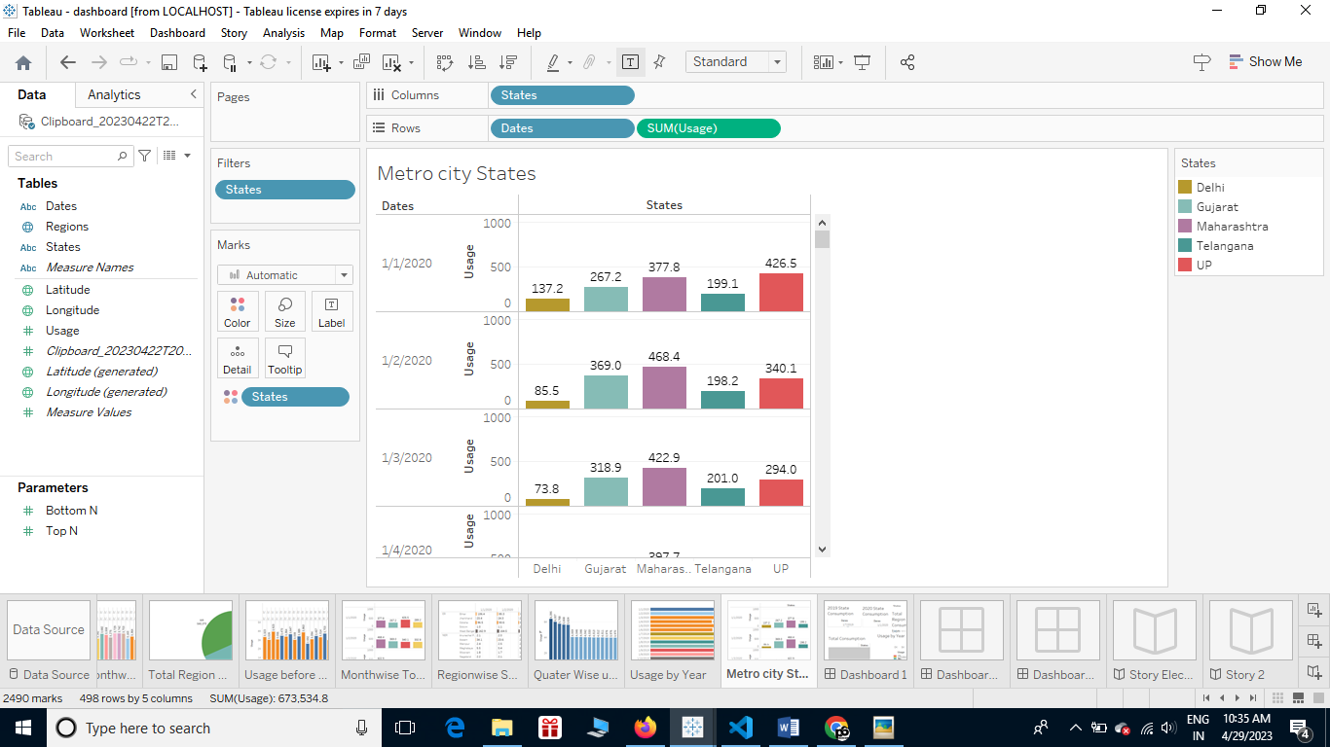

**SHEET 15**

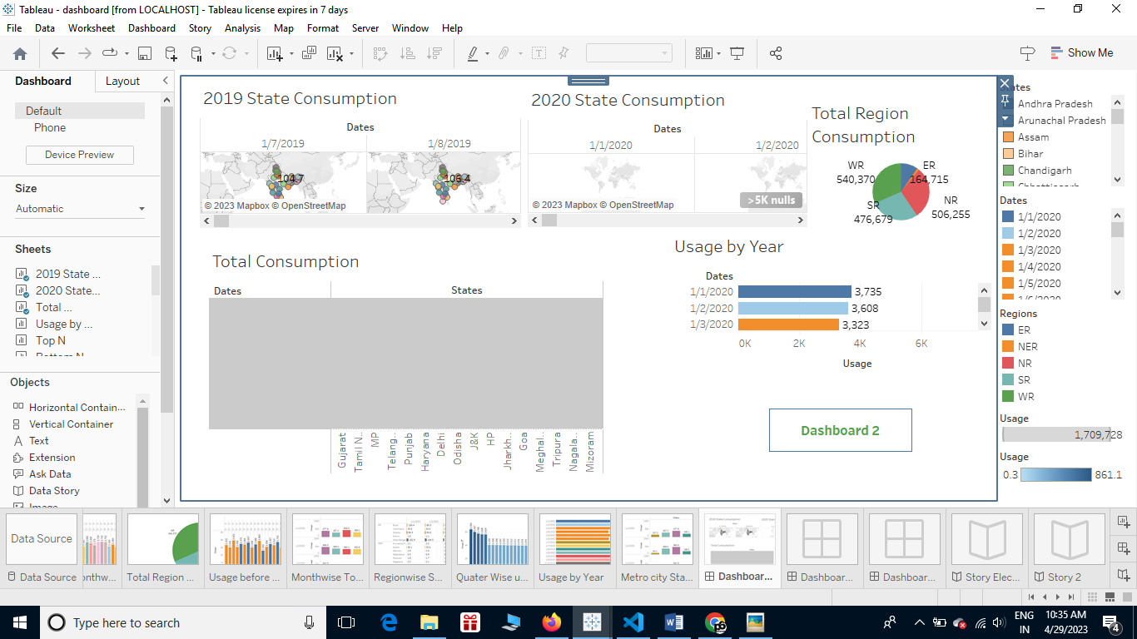

**SHEET 16**

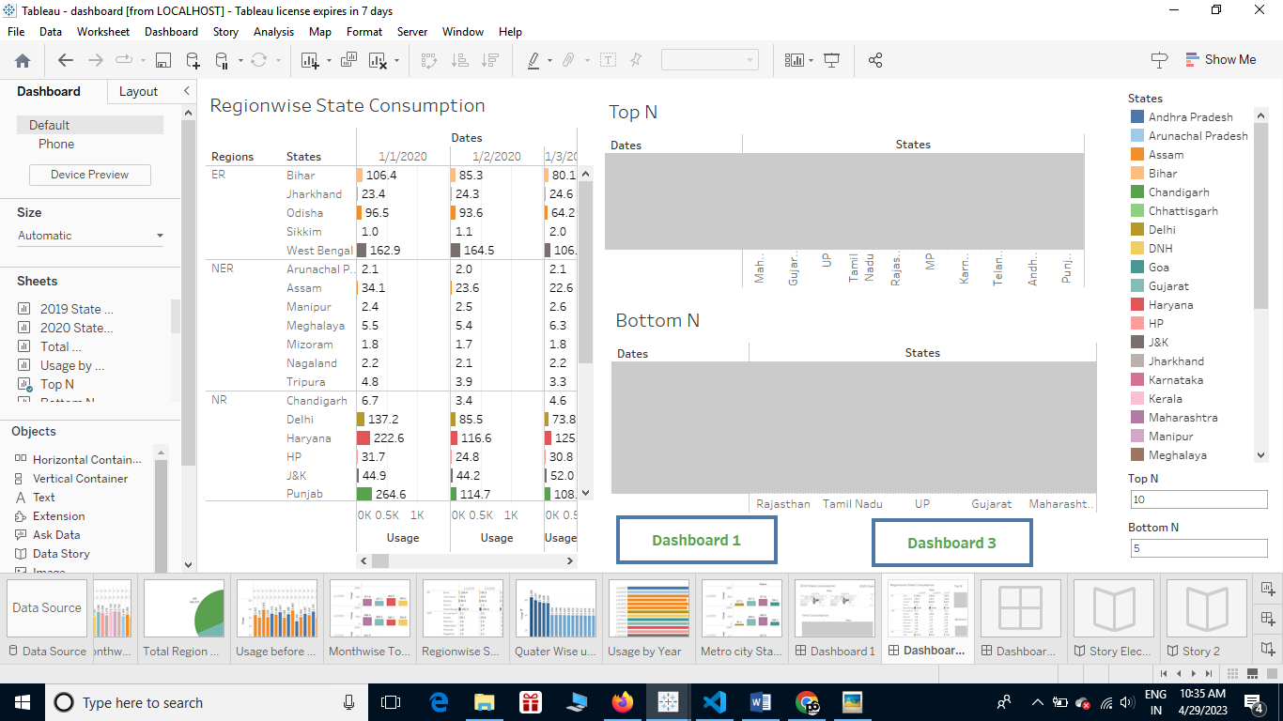

**SHEET 17**

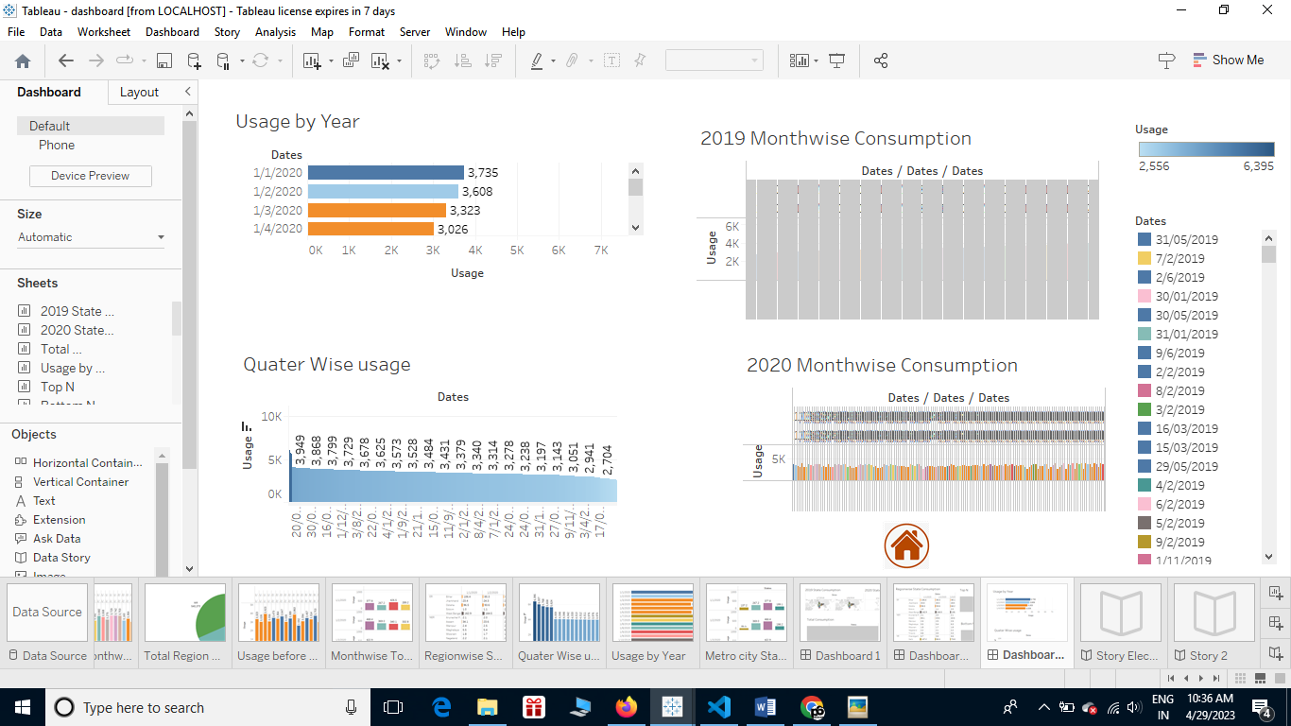

**SHEET 18**

